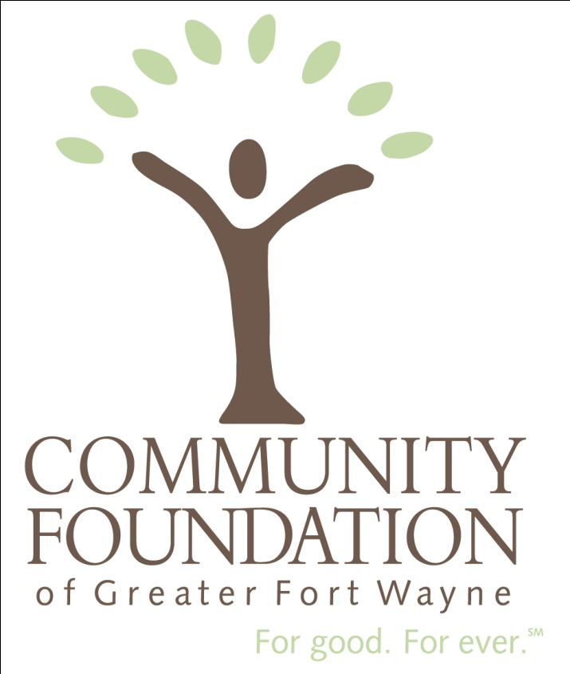

Community Foundation of Greater Fort Wayne

*Loan Program*

The board of the Community Foundation of Greater Fort Wayne has agreed to provide loans, or Program Related Investments (PRI), for community and economic development purposes intended to stimulate Allen County’s economic vitality. These funds will be provided by our supporting organization, the Summit Initiatives Foundation. Funds may be awarded to specific municipal, government, or nonprofit projects and organizations that have a direct positive impact on the economic development of Allen County communities that meet certain criteria. Eligible projects must be shown to fit within the overall strategic plan for downtown development.

The ultimate goal of a community or economic development grant is to help create vibrant, economically-integrated neighborhoods and to increase opportunities for low-income residents, ultimately improving quality of life. The Community Foundation must ensure that any loan or PRI made will provide a public benefit and not serve private interests.

Criteria

To ensure that funds are furthering a charitable purpose, community and economic development PRIs and loans must generally fit into one or more of the categories listed below. Charitable activities may, and often do, serve more than one of these purposes.

IRS recognized charitable purposes include:

* Relief of the poor and distressed or of the underprivileged;
* Advancement of education or science;
* Erection or maintenance of public buildings, monuments, or works;
* Lessen the burdens of government; and
* Promote social welfare, eliminate discrimination, or combat community deterioration.

Legally the Community Foundation may not support activities that have a “substantial” non-charitable purpose or result in inurnment to private entities or persons. Unfortunately there is no clear method to differentiate substantial from insubstantial; each request must be evaluated on its specific facts and circumstances. The key is to make certain the primary focus and beneficiaries of the grant are a broad-based group that fits within the tax code definition of a charitable purpose as outlined above. The ultimate goal of this type of investment is not the production of income or the appreciation of property.

To determine whether a community development group furthers a charitable purpose, the IRS requires that the PRI or loan satisfy the following three criteria:

1. Funding must either help a local business or help attract a new local office or facility of an established outside business.
2. Any PRIs or loans must have non-commercial terms and have the potential to revitalize a disadvantaged area.
3. There must be a link or connection between the businesses being assisted and relieving the problems of the disadvantaged area, or a link between the businesses and a disadvantaged group, such as a minority, elderly, disabled, or the chronically unemployed in the area.

Each project will be analyzed using a two-step process. **Step One** is designed to ensure that the project meets an IRS-recognized charitable purpose. In order to receive support, the evaluator must answer “yes” to at least one question in **Step One**.

The questions in **Step Two** are designed to determine if the project furthers a charitable purpose. While there is no “right” or “wrong” answer to these questions, a higher number of “yes” answers provides stronger evidence that the project furthers a charitable purpose.Assessing Community and Economic Development Projects

This assessment tool is designed to help board and staff evaluate whether a community or economic development project complies with charitable purposes as defined by the IRS and is a project that the Community Foundation is interested in pursuing.

|  |  |  |  |
| --- | --- | --- | --- |
| **Step One:**  Does the community or economic development project  “substantially” focus on the: | | | |
|  |  | Yes | No |
| 1 | Relief of the poor, distressed, or underprivileged? |  |  |
| 2 | Advancement of education or science? |  |  |
| 3 | Erection/maintenance of public buildings, monuments, or works? |  |  |
| 4 | Lessening the burdens of government? |  |  |
| 5 | Promotion of social welfare to accomplish any of the above, lessen neighborhood tensions, eliminate prejudice, or discrimination or combat community deterioration? |  |  |

|  |  |  |  |
| --- | --- | --- | --- |
| **Step Two:**  Does the community or economic development project: | | | |
|  |  | Yes | No |
| 1 | Replace one previously undertaken by the government? |  |  |
| 2 | Play an integral part in a larger governmental program/project? |  |  |
| 3 | Feature an organization acting jointly with a governmental unit? |  |  |
| 4 | Involve a governmental unit inviting the Community Foundation to participate in the program/project? |  |  |
| 5 | Have a government ruling that has identified the area as “economically disadvantaged”? |  |  |
| 6 | Support the overall strategic vision/plan for downtown development? |  |  |
| 7 | Provide help to local business or attract new local facilities of established outside business? |  |  |
| 8 | Provide the type of assistance to the community development organization that has non-commercial terms and the potential to revitalize a disadvantaged area? |  |  |
| 9 | Result in job opportunities? |  |  |

Additional items to consider:

|  |  |  |  |
| --- | --- | --- | --- |
| 1 | Is property currently occupied? |  |  |
| 2 | Has a developer already been selected? |  |  |
| 3 | Will the project go out to bid? |  |  |
| 4 | Type of Structure? | Current? | Planned? |
|  | Residential |  |  |
|  | Commercial |  |  |

Note:

1. Loan recipients may use the loan funds only for the purposes for which the grant was made;
2. Loan recipients will be required to provide periodic written reports concerning the use of grant funds;
3. Loan recipients will be required to submit a final written report, including an accounting of how loan funds were used; and,
4. The Summit Initiatives Foundation has the authority to withhold and/or recover loan funds in case such funds are, or appear to be, misused.