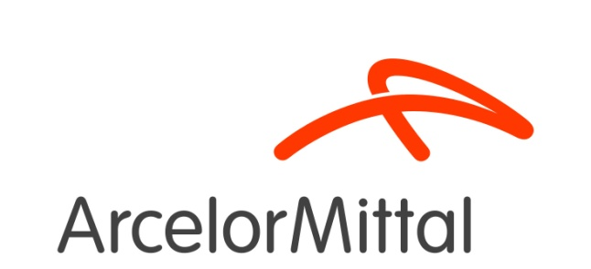

ASSUMPTION OF RISK, RELEASE OF LIABILITY AND INDEMNITY AGREEMENT for July 24, 2018 Global Research and Development East Chicago
The undersigned (“Visitor”) acknowledges that ArcelorMittal and ArcelorMittal Global Research and Development East Chicago (“Owner”) are extending a special privilege in allowing Visitor on Owner’s property (the “Premises”) on Tuesday, July 24, 2018. In consideration of the privilege to access the Premises, Visitor hereby acknowledges, agrees and represents the following:

- LABORATORY TOUR DRESS CODE – applies ONLY to those going on the LABORATORY TOUR. You must wear long pants – no shorts, capri pants or dresses. Low heeled, closed toe shoes or boots – no sandals, flip flops or high heels. Proper PPE such as safety glasses/hearing protection, etc. will be provided by ArcelorMittal.

- RELEASE. Visitor fully releases and forever discharges Owner and its affiliates, officers, directors, employees and agents, for, from and against any and all present and future liabilities, obligations, damages, losses, claims, demands, costs or expenses (collectively, “Claims”) that may be made by Visitor, or Visitor’s family, estate, heirs or assigns related in any way to Visitor’s presence on the Premises (including in connection with transportation to or from the Premises), including, without limitation, Claims for loss, theft, damage to property, personal injury or wrongful death.

- ASSUMPTION OF RISK. Visitor understands and acknowledges that Owner’s production and manufacturing facilities, including the Premises, contain inherent risks and hazards, including but not limited to risks involving vehicles, moving machinery, equipment, uneven or slippery surfaces, explosion, fire, smoke, gases, steam, chemicals, emissions, and other hazardous conditions. Visitor voluntarily elects to enter the Premises and voluntarily assumes all risks of loss, damage, or injury that may be sustained by Visitor, or Visitor’s property or personnel, while on the Premises.

- INDEMNIFICATION. Visitor fully agrees to indemnify and hold harmless Owner and its affiliates, officers, directors, employees and agents, from any and all Claims, made by Visitor or any other party, related in any way to Visitor’s presence on the Premises (including in connection with transportation to or from the Premises), even if caused by Owner’s negligence.

- PHOTO/VIDEO. I consent to the display, reproduction or other use of photographs and/or provided materials (artwork, testimonial, quote, video) by ArcelorMittal or its affiliates. I agree that these photos and/or materials may be used by ArcelorMittal for internal or external communication, promotional or other company purposes. I waive all rights and acknowledge that ArcelorMittal will have all rights to use the photos and/or materials.

Date: ________________________________________________________

Organization: _________________________________________________

Visitor name: _________________________________________________

Visitor Signature: ______________________________________________

